**Problem Set 2.2**

No. 1



Auxiliary equation:







General sol.: 

No. 2



Auxiliary equation:





General sol.: 

No. 3



Auxiliary equation:







General sol.: 

No. 4



Auxiliary equation:







General sol.: 

No. 5



Auxiliary equation:



 Double root



General sol.: 

No. 6



Auxiliary equation: 

 Double root



General sol.: 

No. 7



Auxiliary equation: 





General sol.: 

No. 8



Auxiliary equation:





General sol.: 

No. 9



Auxiliary equation:







General sol.: 

No. 10



Auxiliary equation:







General sol.: 

No. 11



Auxiliary equation: 





General sol.: 

No. 12



Auxiliary equation: 





General sol.: 

No. 13



Auxiliary equation: 

 Double root



General sol.: 

No. 14



Auxiliary equation: 

 Double root



General sol.: 

No. 15



Auxiliary equation:





General sol.: 

No. 16





Auxiliary equation: 

ODE 

No. 17



 (double root)

Auxiliary equation: 

ODE 

No. 18





Auxiliary equation: 

ODE 

No. 19





Auxiliary equation:





ODE 

No. 20





Auxiliary equation:





ODE 

No. 21



Auxiliary equation:





General sol.: 



With the initial values 





Particular sol.: 

No. 22

In Prob.4 





With the initial values 

 



With,

Particular sol.: 

No. 23



Auxiliary equation: 





General sol.: 



With the initial values 







Particular sol.: 

No. 24



Auxiliary equation:





General sol.: 



With the initial values 







Particular sol.: 

No. 25



Auxiliary equation:





General sol.: 



With the initial values 



  and 

Particular sol.: 

No. 26



Auxiliary equation:





General sol.: 



With the initial values 

 



Particular sol.: 

No. 27

In Prob. 5, the general sol.: 



With the initial values 





Particular sol.: 

No. 28



Auxiliary equation: 





General sol.: 



With the initial values 



 or 



Particular sol.: 

No. 29

In Prob. 15, the general sol.: 





With the initial values 





Particular sol.: 

No. 30



Auxiliary equation: 

 Double root



General sol.: 



With the initial values 





Particular sol.: 

No. 31

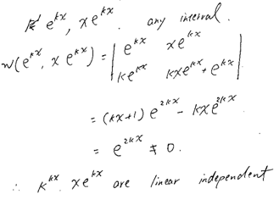

No. 32

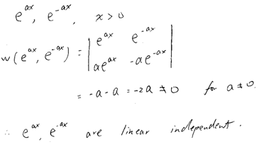

No. 33

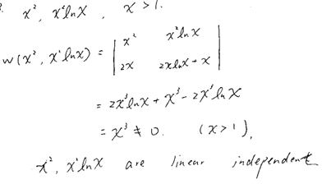

No. 34

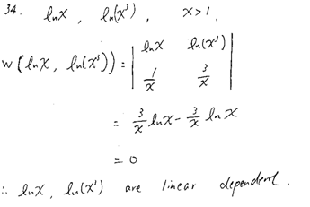

No. 35





Linearly dependent

No. 36



Linearly independent

No. 37



General solution

Particular sol.: 

If 

Particular sol.: 

Since in the particular solution, the coefficient of changes, as x increases change significantly.

No. 38

(a)



(b)(i) Present method







and are the solution basis.

(ii) Reduction method   





and are the solution basis.

(c)

And the equation with 

If 



Putand  into the differential equation



  not double root

 is not a solution

(d) If and 

Thenand  are solution basis.

is also a solution



Apply d’Hospital’s rule

